Task 1: Bridge
Consider a shape display system which can display shapes in several output formats.
All shape classes in the system have a deferred class SHAPE as their ancestor. For example, the following figure shows part of the shape hierarchy:
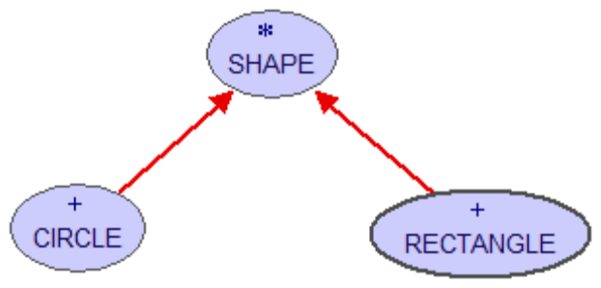
Classes SCREEN and PRINTER are used to display shapes on a screen or printer respectively:
class SCREEN
feature
draw_line (x1, y1, x2, y2: INTEGER) is … ‐‐ Display a line from (x1, y1) to (x2, y2).
draw_pixel (x, y: INTEGER) is … ‐‐ Display a pixel at (x, y).
draw_circle (x, y, r: INTEGER) is … ‐‐ Display a circle at (x,y) with radius r.
end
class PRINTER feature
print_line (x1, y1, x2, y2: INTEGER) is … ‐‐ Print a line from (x1, y1) to (x2, y2).
print_pixel (x, y: INTEGER) is … ‐‐ Print a pixel at (x, y).
print_circle (x, y, r: INTEGER) is … ‐‐ Print a circle at (x,y) with radius r.
end
- Design a system which allows new shapes and new output formats to be added easily. You are required to add a new shape POLYGON and a new output format XML_WRITER.
- Draw a class diagram to illustrate your design.

Task 2: Mediator
- Given the files in lab9Code folder, write the mediator classes so that the demo give the following output. This mediator will mediate the communication between two buyers (a Swedish buyer and a French buyer), an American seller, and a currency converter.

Buyer attempting a bid of 55.0 krona
Converting 55.0 kronor to 6.875 dollars
Seller rejects the bid of 6.875 dollars

Buyer attempting a bid of 70.0 krona
Converting 70.0 kronor to 8.75 dollars
Seller rejects the bid of 8.75 dollars

Buyer attempting a bid of 85.0 krona
Converting 85.0 kronor to 10.625 dollars
Seller accepts the bid of 10.625 dollars

Buyer attempting a bid of 3.0 euro
Converting 3.0 euros to 4.285714 dollars
Seller rejects the bid of 4.285714 dollars

Buyer attempting a bid of 4.5 euro
Converting 4.5 euros to 6.4285717 dollars
Seller rejects the bid of 6.4285717 dollars

Buyer attempting a bid of 6.0 euro
Converting 6.0 euros to 8.571428 dollars
Seller rejects the bid of 8.571428 dollars

Buyer attempting a bid of 7.5 euro
Converting 7.5 euros to 10.714286 dollars
Seller accepts the bid of 10.714286 dollars

- Draw a class diagram to illustrate your design.

